**Muhammad Umar Ahmadzai**

**09/15/2017**

**Extra Assignment: Stamp Machine**

**Problem Statement:**

This program is going to ask user to enter the number of pennies. The program will input the data and convert the pennies in sorted format to dollars, quarters, dimes and nickels. The program is also going to show the remaining pennies from dollars, quarters, dimes and nickels.

**Input/output Description:**

Asking user to enter the amount of pennies and inputting it:

cout << "Please enter the amount of Pennies to covert:";

cin >> pennies;

Will show the amount in dollars, and the remainder from dollars:

cout << "Amount of Dollars:" << dollars << endl;

cout <<"Remainder from Dollars:"<< remainder << endl << endl;

Will show the amount in quarters, and the remainder from quarters:

cout << "Amount of Quaters:" << quaters << endl;

cout << "Remainder from Quaters: "<< remainder << endl << endl;

Will show the amount in dimes, and the remainder from dimes:

cout <<"Amount of Dimes:" << dimes << endl;

cout <<"Remainder from Dimes:" << remainder << endl << endl;

Will show the amount in nickles, and the remainder from nickles:

cout << "Amount of Nickles:" << nickles << endl;

cout << "Remainder from Nickles:" << remainder << endl << endl;

Will show the final remainder:

cout <<"Final Remainder in Pennies:" << remainder << endl;

**Algorithm Development:**

Basically, we are defining dollars, quarters, dimes, nickels, pennies, remainder. User is going to be asked to input number of pennies, it will be stored in pennies. Formula applied will convert the number of pennies for dollars, quarters, dimes, and nickels. For instance, it will divide number of pennies for dollars by 100 and will find the remainder by taking modulus 100. Remainder variable will store the remainder amount from each form of currency and will find the remaining balancing applying it to all forms.

**Program Listing:**

#include <iostream>

using namespace std;

int pennies, nickles, dimes, quaters, dollars, remainder;

int main()

{

cout << "Please enter the amount of Pennies to covert:";

cin >> pennies;

dollars = pennies / 100;

remainder = pennies % 100;

cout << "Amount of Dollars:" << dollars << endl;

cout <<"Remainder from Dollars:"<< remainder << endl << endl;

quaters = remainder / 25;

remainder = remainder % 25;

cout << "Amount of Quaters:" << quaters << endl;

cout << "Remainder from Quaters: "<< remainder << endl << endl;

dimes = remainder / 10;

remainder = remainder % 10;

cout <<"Amount of Dimes:" << dimes << endl;

cout <<"Remainder from Dimes:" << remainder << endl << endl;

nickles = remainder / 5;

remainder = remainder % 5;

cout << "Amount of Nickles:" << nickles << endl;

cout << "Remainder from Nickles:" << remainder << endl << endl;

cout <<"Final Remainder in Pennies:" << remainder << endl;

return 0;

}

**Observation and Error Handling and general comments:**

Did not faced any errors.

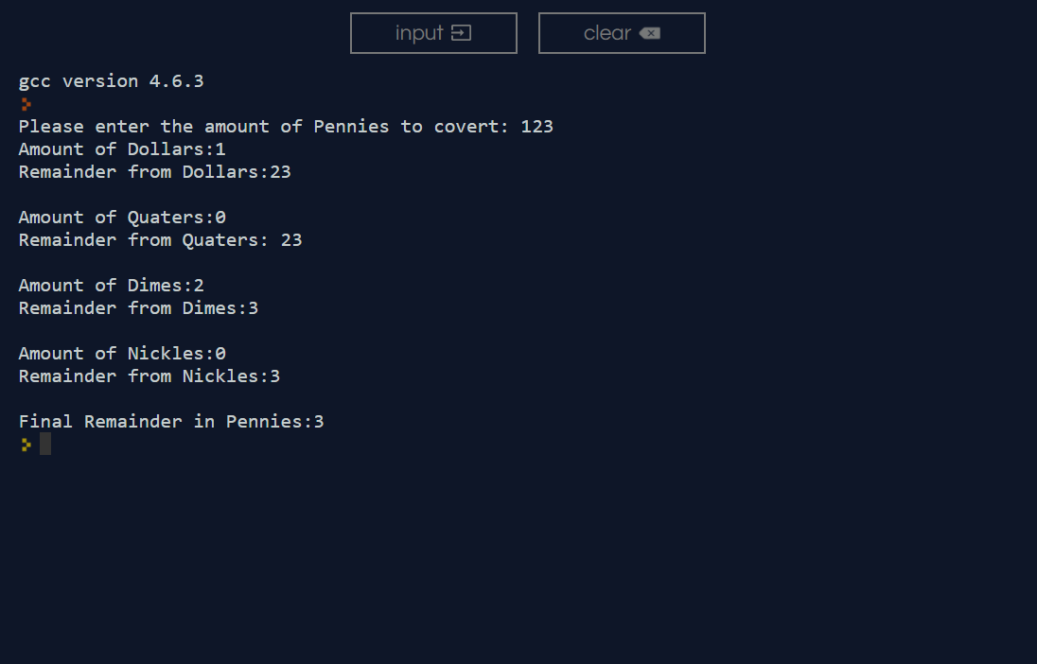

**Conclusion:**

In conclusion, it will output and convert pennies into dollars, quarters, dimes and nickels and will show the remainder as well for dollars, nickels, dimes, and quarters.